Genesis vs. Revelation
✨ Theme | 🌱 Genesis  (Beginning; Creation) | 🌅 Revelation  (Redemption; Completion)
Earth | Created (1:1) | Passed Away (21:1)
Heavenly Lights | Sun, Moon, Stars Made (1:14–16) | Struck / Darkened (4:12; 8:12)
Light Source | Sun Governs Day (1:16) | Sun Not Needed (21:23)
Night | Darkness Called Night (1:5) | No Night There (22:5)
Seas | Waters Called Seas (1:10) | No More Sea (21:1)
River | River Blessing the Earth (2:10–14) | River of Life (22:1–2)
Humanity | Man in God’s Image (1:26) | Man Ruled by Beast’s Image (13)
Sin | Sin Enters (3) | Sin Removed (21–22)
Curse | Curse Pronounced (3:14–17) | Curse Removed (22:3)
Death | Death Enters (3:19) | Death Abolished (21:4)
Sorrow | Sorrow Enters (3:17) | Sorrow Removed (22:4)
Eden | Man Expelled (3:24) | Man Restored (22)
Tree of Life | Guarded from Man (3:24) | Access Restored (22:14)
Cherubim | Introduction (3:24) | Final Mention (19:4)
Flood | God Judges Evil World (6–9) | Satan Attacks Remnant (12)
Covenant Sign | Rainbow Given (9:13) | Rainbow Remembered (4:3; 10:1)
City of Rebellion | Babylon Founded (10:8–10) | Babylon Destroyed (17–18)
Corrupt Cities | Sodom & Egypt Judged (13; 19) | Jerusalem Called “Sodom & Egypt” (11:8)
Abraham’s People | Coalition Against Them (14) | Woman Protected (12)
Bride | Bride for Isaac (24) | Bride of the Lamb (19)
Marriage | First Adam Married (2:18–23) | Last Adam Married (19)
Seed Promise | Gate of Enemies Possessed (29:8) | Dominion Fulfilled (19)
Dominion | Lost to Satan (3:24) | Restored to Man (22)
Prophetic Scriptures  8,362 predictive verses  1,817 predictions  737 separate matters  J. Barton Payne, Encyclopedia of Biblical Prophecy | One Integrated Design  The NT is in the OT concealed.  The OT is in the NT revealed.  404 Verses containing over 800 allusions to OT

Major Prophetic Themes
• Israel • Jerusalem • Temple • Babylon • Russia (Magog) • Rise of China • European Super State • Ecumenical Religion • Global Government • Rise of the Occult

Applies today; the more you know, the more it is revealed.

The Structure and The Seven
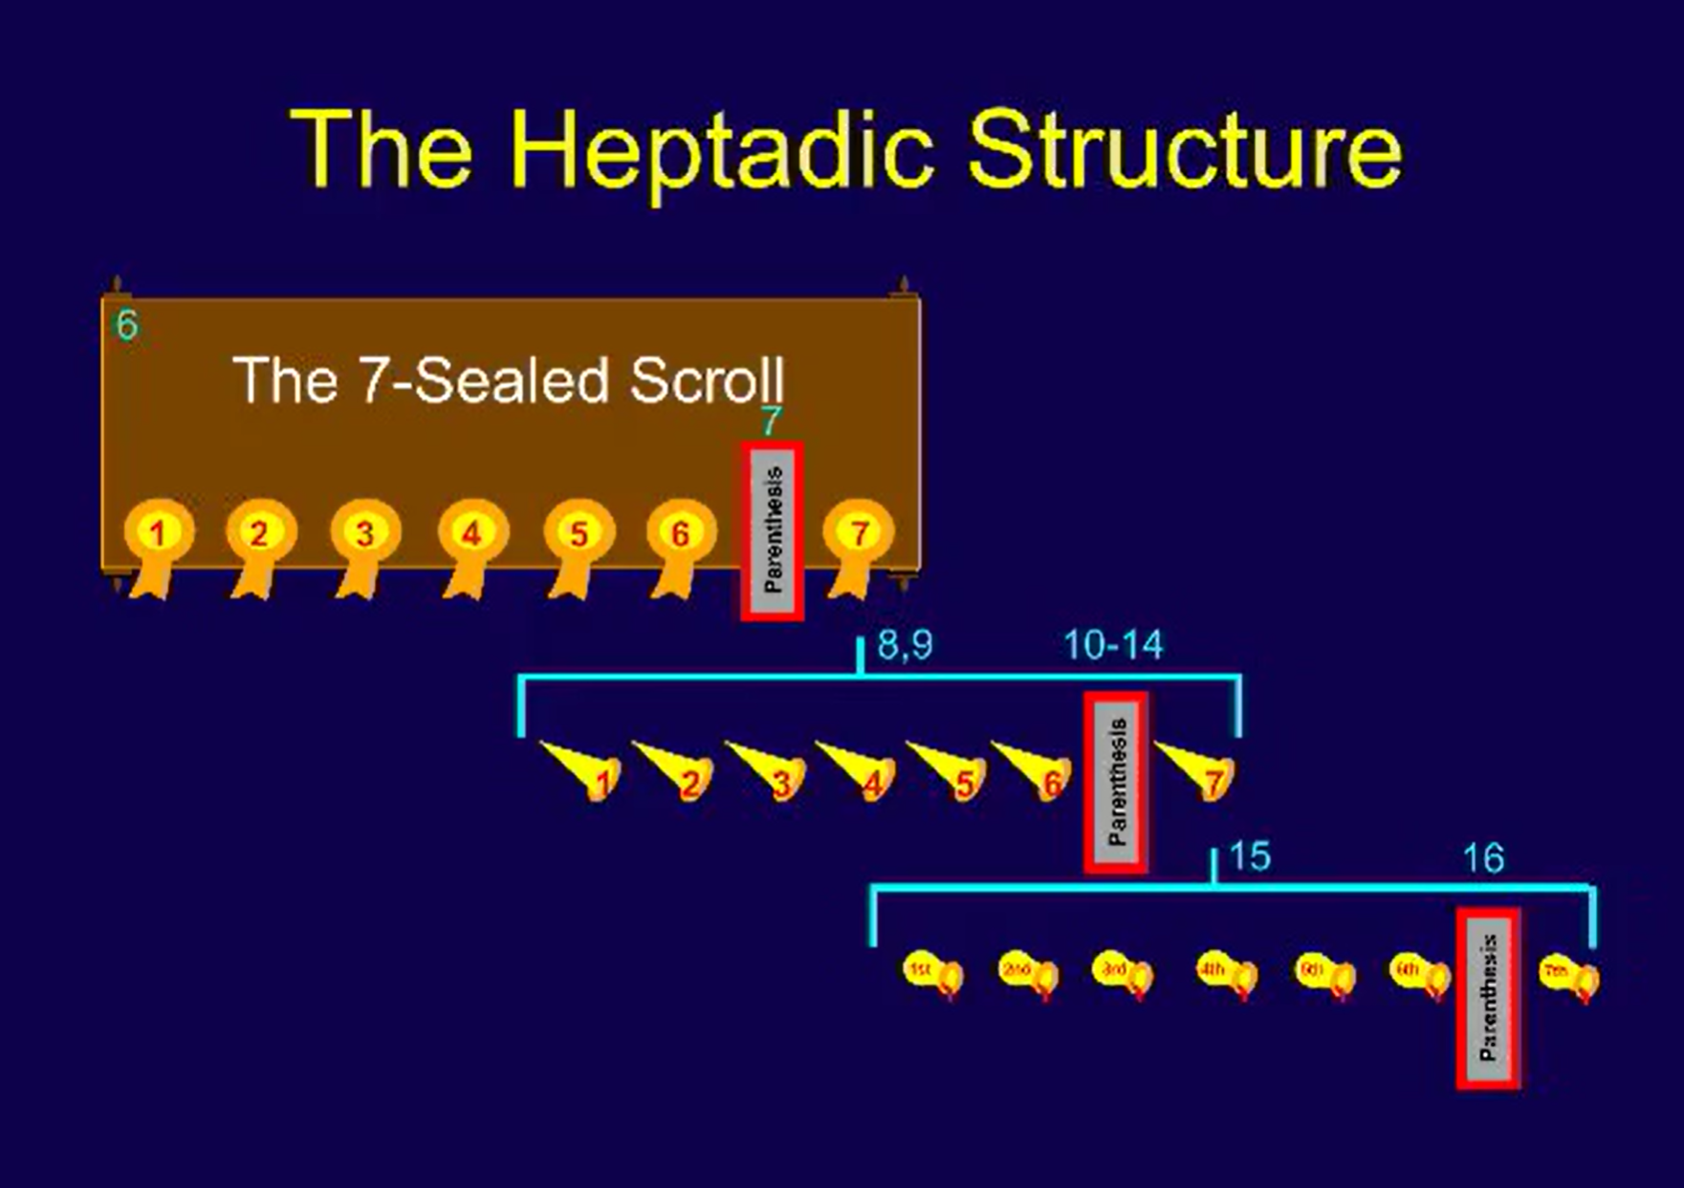

View of a Perspective of the Book of Revelation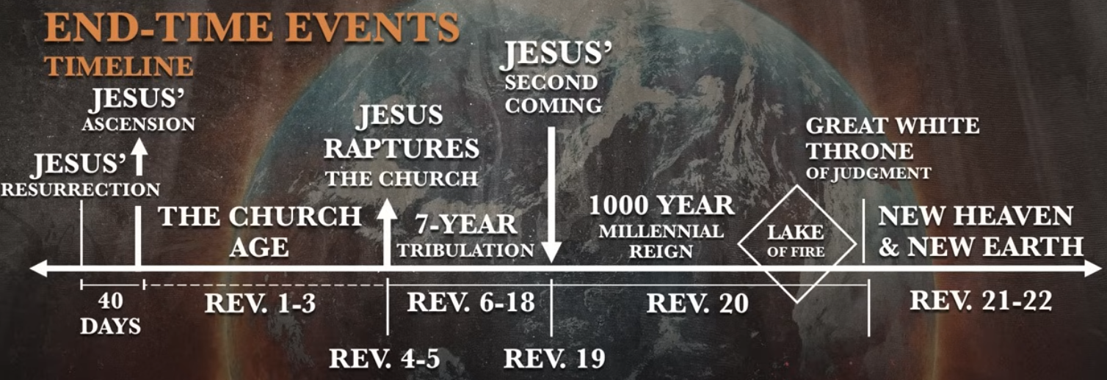

Four Viewpoints of Revelation
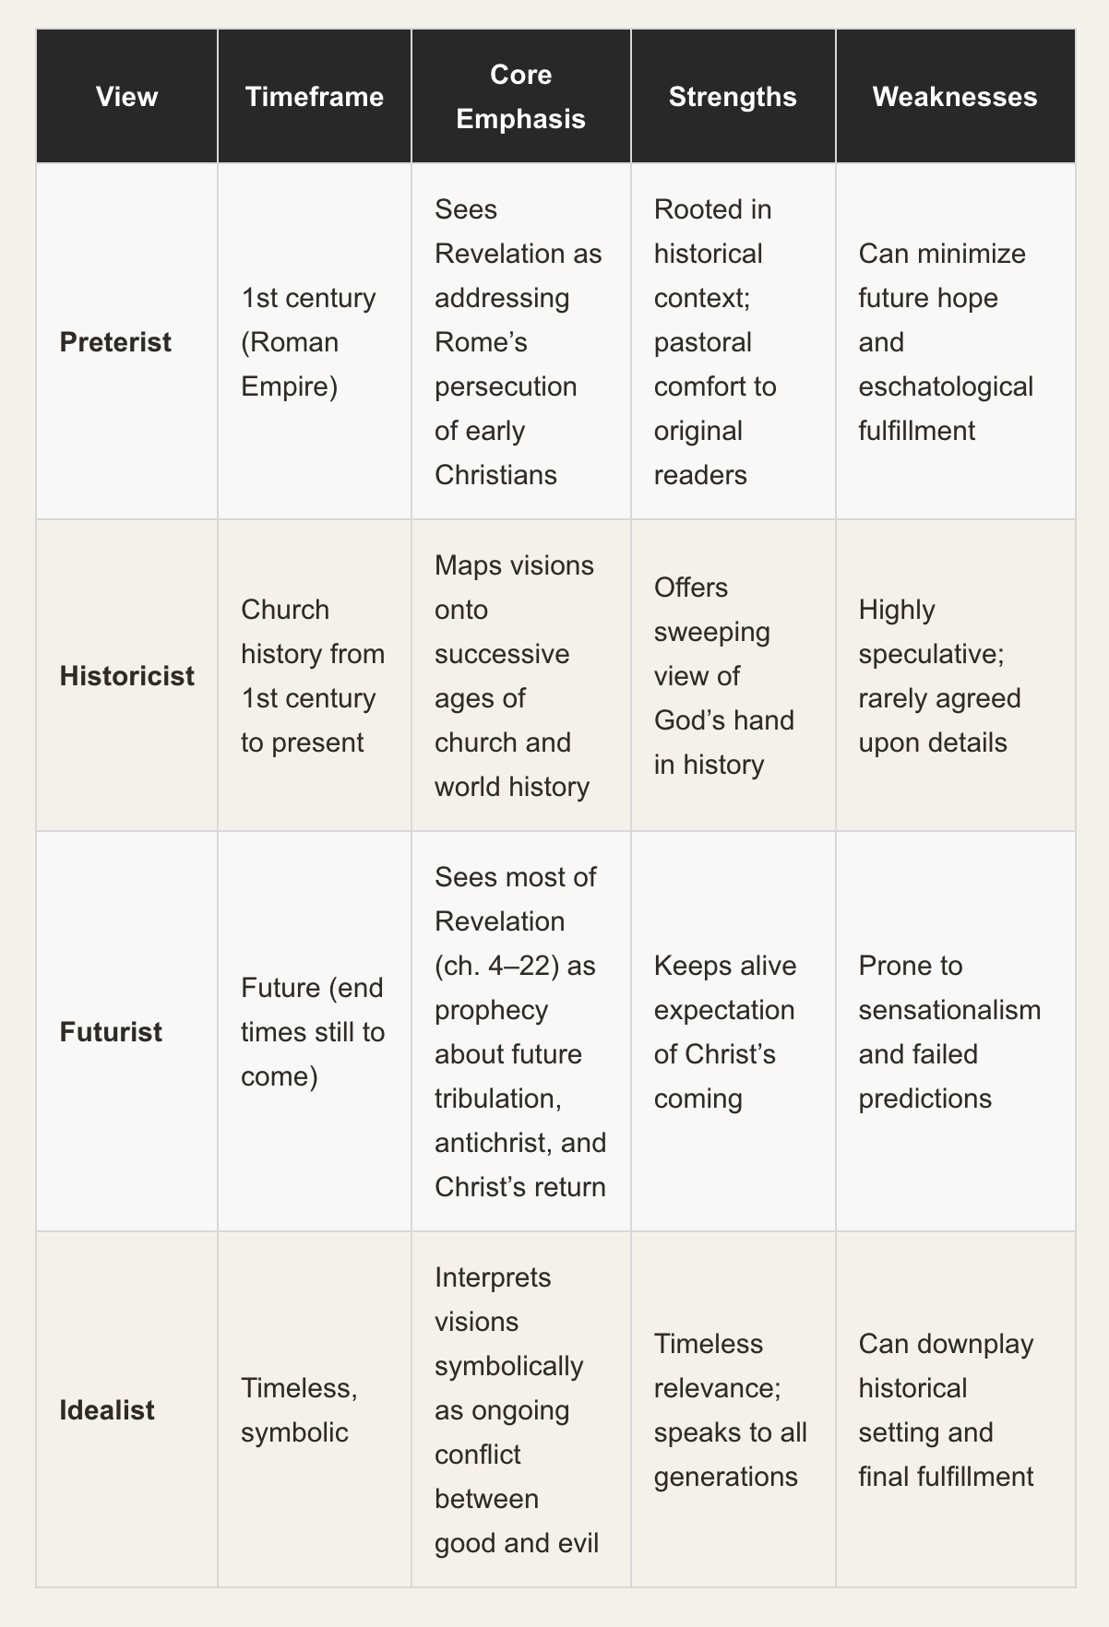

Bible Connections
