The 70th Week (Book of Daniel)
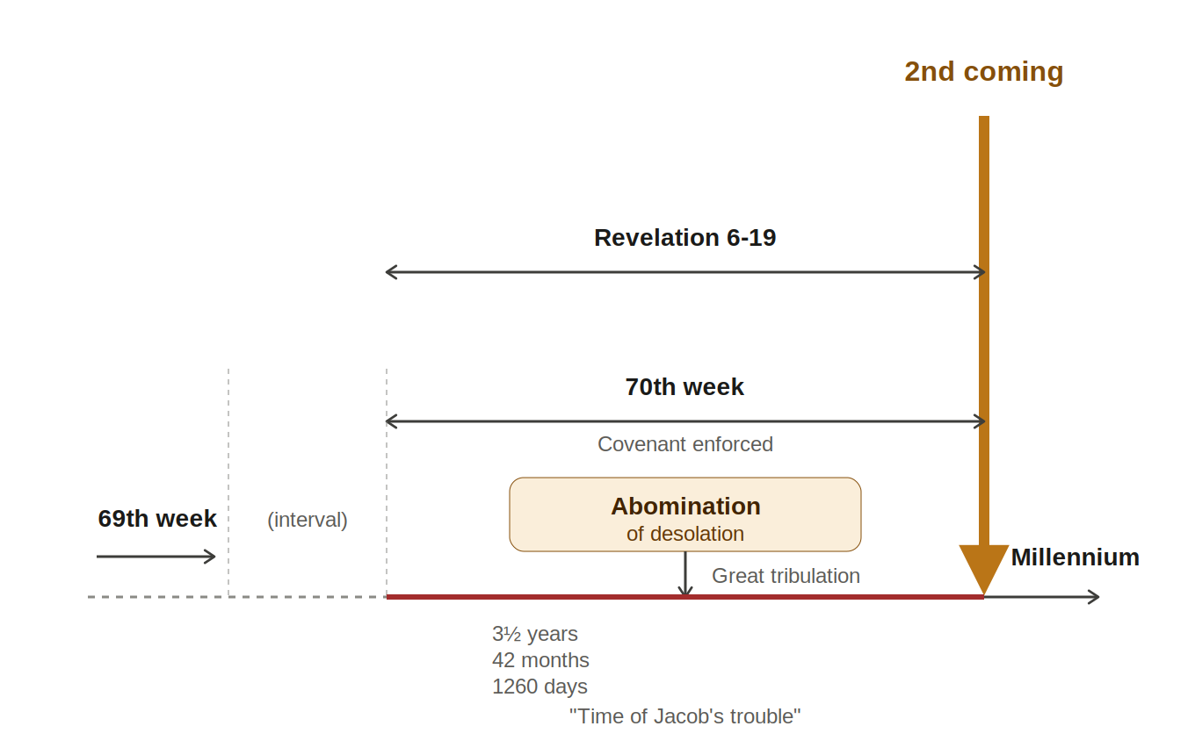

The Heptadic Structure
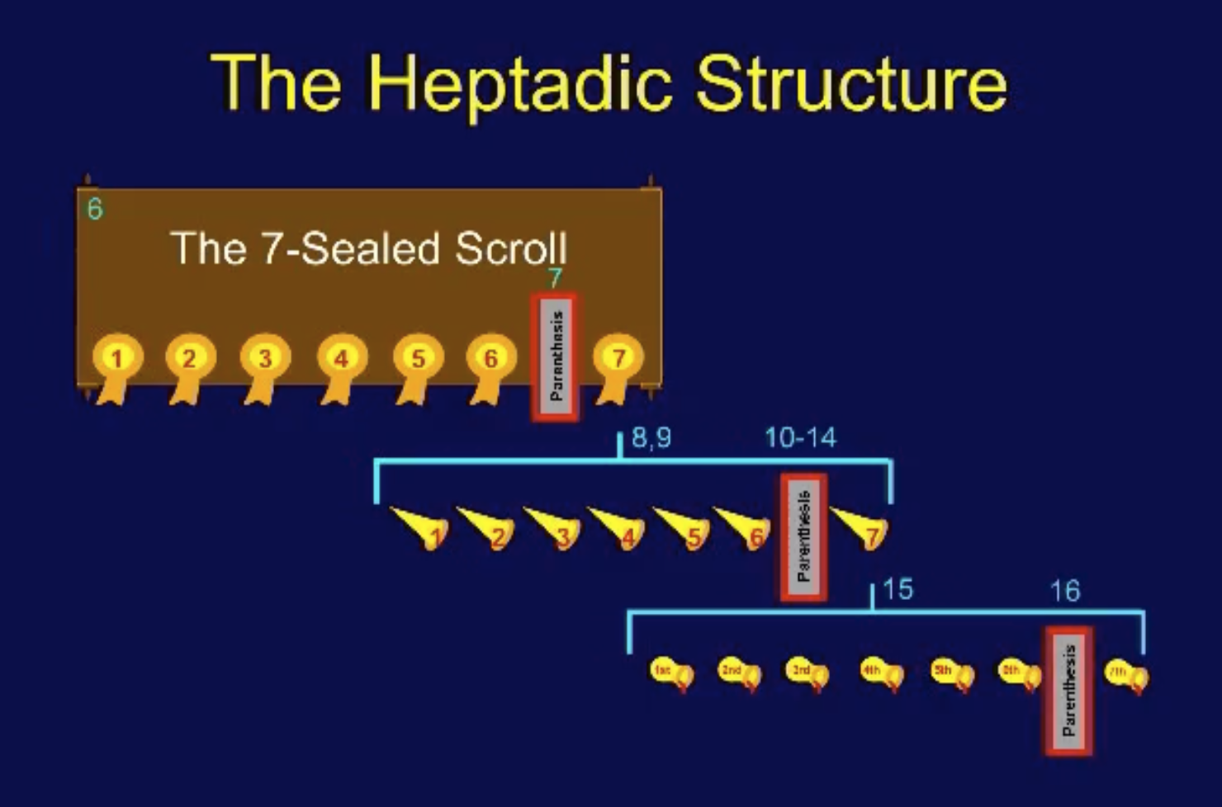

Group of Signs
 | Matthew | Luke | Revelation
False Christs | 24:4-5 | 21:4 | 6:1-2
Wars | 24:6 | 21:9,10 | 6:3-4
Famine | 24:7a | 21:11 | 6:5-6
Death | 24:7b-8 | 21:12 | 6:7-8
Martyrs | 24:9 | 21:24 | 6:9-11
Global Upheaval | 24:10-13 | 21:25 | 6:12-17
