REVELATION CHAPTER 4
The Throne Room of Heaven
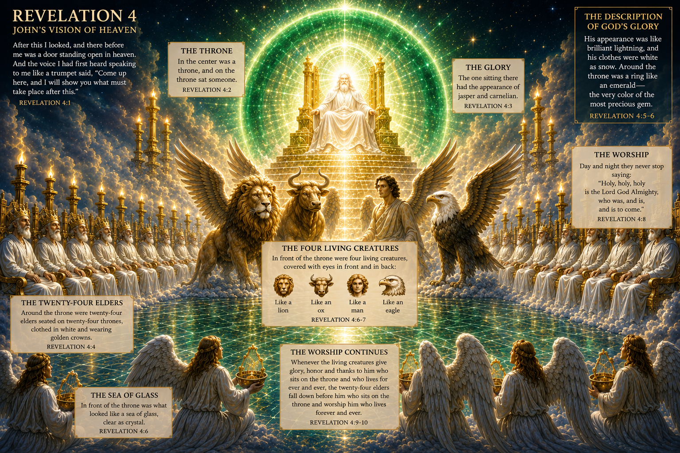
Revelation 4 — John's Vision of Heaven

PART A — REVELATION 4:1–6

The Throne and the One Who Sits Upon It

Introduction
1. As we begin chapter 4, something significant happens in the book of Revelation. From here on, there is no mention of the church on earth until the Second Coming of Christ. Many scholars believe there is a reason for this. Only Tribulation Saints—people who accept Christ after the Rapture—are present during this time of suffering and judgment. The church is not present for God's wrath. Rather, the church has been caught up in the air to be with Him, our Bridegroom. Later in our discussion of this chapter, we will briefly discuss some of the main passages that support this view.
2. Chapter 4 begins with a heavenly perspective looking down upon the earth. In describing heavenly things, John uses symbols. However, we need to remember that not EVERYTHING is necessarily symbolic. As in the parables of Jesus, many details may simply be descriptive and are not necessarily intended to carry some special significance on their own.
3. If you get the chance, there is an excellent documentary/movie called Before the Wrath. It uses the ancient Galilean wedding customs as a picture supporting the Rapture view. I will also share some of my own thoughts as we continue through Revelation about why I believe in the Rapture view.
4. We should also keep in mind the nature of symbolism: The symbol is always less than the reality. Whatever John is attempting to describe, the reality of heaven is even greater than the description we have of it!
5. Revelation 4–19 is mainly concerned with God's judgment upon the world preceding Jesus' earthly reign. This period is often referred to as the Great Tribulation.
6. God's judgments will eventually be announced through a seven-sealed scroll, seven trumpets, seven signs, and seven bowls that pour out God's wrath.
7. Revelation 4, then, introduces us to the place from which this judgment comes: God's throne in heaven.

Verse 1 — An Open Door into Heaven
8. What happens in verse 1?
John is called up into heaven and once again hears a voice speaking to him.
9. What does the voice sound like this time?
Like a trumpet! It was obviously loud and clear—almost like an army being called into battle. Some see John's going up into heaven as a picture or symbol of the Rapture of the church. John is called to heaven with the sound of a trumpet, similar to what Paul describes concerning the church in 1 Thessalonians 4:16–17. This does not necessarily mean John's experience is the Rapture, but there are certainly interesting similarities.
10. What else stands out to you about John's ascension into heaven?
John did not simply watch these things happen through an open door. He was invited through the open door into the heavenly realm. Jesus was going to personally show him the things that would happen—things that were about to “come to be.” Imagine having the honor of seeing this!

Verse 2 — “In the Spirit”
11. Verse 2 provides additional details about John's experience. What do we learn here?
John says: “Immediately I was in the Spirit.”
12. Let's talk about this a little more. What do you think is meant here? Where was John's body?
John uses the phrase “in the Spirit” four times in Revelation. Commentators differ on exactly what John experienced. It appears that John entered some kind of Spirit-directed prophetic state in which he was shown realities in the heavenly realm. What this actually looked or felt like may be impossible for us to know. But the implication is clear: John was given access to the heavenly realm as these incredible scenes were unveiled before him. After seeing the first vision of Jesus walking among the lampstands and receiving the messages to the seven churches, John is now shown something even greater: the throne room of heaven.
13. What we are not told is how much time passed between John's first vision and this one. The human mind can only take so much at one time. My guess is that Jesus may have given John time to process each encounter before revealing the next. We simply aren't told.

The Central Focus — THE THRONE
14. What's the point of focus found in the last part of verse 2?
A THRONE! John uses the word throne repeatedly throughout Revelation, and it dominates this chapter. God's throne is the governmental center of the universe.
15. The throne is what first impresses John, and it becomes the centerpiece of this entire vision. John becomes fixated upon the throne and the One who occupies it. Everything else John sees is described in relation to this throne. Before John is shown what is going to happen on earth, he is shown Who is sitting on the throne in heaven.

Verse 3 — The One Sitting on the Throne
16. As we come to verse 3, John describes WHAT—or more importantly WHO—he saw on that heavenly throne. What stands out to you?
Once again, try to put yourself in John's shoes. He is attempting to describe to his readers something completely otherworldly—something for which the language of his day may not even have had adequate words.
17. Depending upon the translation you use, you might find the appearance of the One sitting on the throne described using jasper and carnelian, also called sardius. Rather than describing a specific physical form or figure, John describes what appears to be brilliant emanations of glistening light. Jasper in this context may refer to something clear and brilliant, almost like crystal or diamond. Carnelian, also known as sard, is reddish in color and commonly described as a glassy, translucent, semi-precious gemstone. What an incredible sight this must have been!

The Emerald Rainbow
18. What about the rainbow surrounding the throne?
This doesn't appear to be simply a typical rainbow as we normally picture one. John describes something like an emerald rainbow completely surrounding the throne—perhaps like a magnificent halo of light. The Greek wording even allows for the idea of “a rainbow like an emerald.” (See—I knew God loves the Irish!)
19. Why would the rainbow be significant?
The rainbow immediately reminds us of God's covenant with Noah. It therefore provides a beautiful picture of God's mercy, faithfulness, and covenant love. John is about to witness God's judgment upon the earth. Yet surrounding the very throne from which judgment proceeds is a reminder of God's covenant faithfulness and mercy. God is perfectly holy and perfectly just, but He is also merciful and faithful. Jasper. Carnelian. Emerald. What an amazing scene!

Verse 4 — The Twenty-Four Elders
20. Moving on to verse 4, John describes what he saw around the throne. What did he see first?
Before the elders themselves caught John's attention, he noticed the twenty-four thrones upon which they sat. They were obviously lesser thrones than God's throne—but they must still have been spectacular.
21. What did these twenty-four elders have in common?
- Dressed in white.
- Seated upon thrones.
- Wearing golden crowns.
What is NOT so obvious is exactly who they are or what they represent. So what are your thoughts?
22. Scholars have offered several interpretations of the twenty-four elders. Some believe they represent God's redeemed people, perhaps connected with the twelve tribes of Israel and the twelve apostles. Others believe they are a special order of heavenly beings serving around God's throne. Still others see them as a heavenly council subordinate to God but ruling with delegated authority and wisdom. They may even have some connection to the OVERCOMERS we discussed in the letters to the seven churches.
23. Whether they are glorified humans, heavenly beings, or symbolic representatives, they clearly occupy a position of tremendous honor and authority around God's throne. Before this chapter ends, we're going to see exactly what these elders do with those positions of honor—and with their crowns.

Verse 5 — Lightning, Thunder and Fire
24. As we come to verse 5, John describes some impressive—and even fearful—sights coming from the throne of God. What does he describe?
From the throne come flashes of lightning, rumblings, and peals of thunder. What does this remind you of? The imagery is reminiscent of God's awesome presence at Mount Sinai in Exodus. Lightning, thunder, voices, and fire communicate the overwhelming holiness, power, and majesty associated with the presence of God. This isn't a casual scene. John is standing before the throne of the Almighty God!

The Seven Burning Lamps
25. What else does John see before the throne?
Once again, we see seven lamps—or torches—burning before the throne. By way of reminder: What do they represent? The seven Spirits of God—a picture of the fullness and completeness of the Holy Spirit. The lamps of fire are particularly interesting because the Holy Spirit is ordinarily invisible. Throughout Scripture, however, He sometimes makes His presence visible through physical imagery—such as a dove or tongues of fire. AWESOME!

Verse 6 — The Sea of Glass
26. Finally, what ends this description of the throne in the first part of verse 6?
Before the throne John sees something described as “a sea of glass, like crystal.” Imagine this scene. The blazing torches, brilliant gemstones, flashes of lightning, emerald rainbow, and the glory of God reflected across this enormous crystal-like surface! Commentators have plenty of opinions about exactly what this “sea of glass” represents. But perhaps we shouldn't miss the obvious while looking for symbolism. It must have been absolutely breathtaking.
Now John's attention shifts again. He has shown us the throne, the One seated upon it, the elders surrounding it, the lightning and thunder coming from it, the seven lamps burning before it, and the sea of glass before it. Now John introduces us to the worship taking place around it.

PART B — REVELATION 4:7–11

Worship Around the Throne
The first six verses showed us the incredible majesty of God's throne. Now the focus changes from what John sees to how heaven responds to the One sitting upon the throne.

Verses 7–8 — The Four Living Creatures
1. What do we see around the throne?
John sees four living creatures. There may be significance in the number four because it is often associated with creation—the four winds, four directions, and the created order. Some have even suggested from the imagery that these creatures are intimately connected with God's throne itself. Whatever their precise role, they occupy an extraordinary position immediately around God's throne.
2. What is common among these four living creatures?
They have eyes in front and behind. What might this represent? One possibility is that the eyes represent extraordinary perception and awareness. These are not blind instruments or robots. They see. They perceive. They understand. Their many eyes may symbolize an awareness far beyond anything possessed by ordinary human beings.
3. What else is common among them?
Each of the four living creatures has six wings, and they are described as being full of eyes. Again, what might this represent? Perhaps these living creatures possess extraordinary intelligence, awareness, and perception. They know and understand what is happening around the throne of God.

The Four Different Creatures
4. How does John describe each of the four living creatures?
- The first was like a lion.
- The second was like an ox.
- The third had a face like a man.
- The fourth was like an eagle in flight.
5. What are your thoughts on what these four creatures represent?
There are TONS of interpretations and commentary on this, and I won't take the time to break all of them down here. Study it on your own when you get the chance because there are some fascinating interpretations.
6. It's probably safest to say that these four creatures in some way represent all of animate creation in its excellence. The lion represents the mightiest of wild animals. The ox represents the strength of domesticated animals. The eagle represents the greatness of the birds. And man represents humanity. These living beings may therefore be considered representatives of the whole created order gathered around the throne of its Creator.

Verse 8 — “Holy, Holy, Holy”
7. In the last part of verse 8, what do these creatures do?
They worship God continually, saying: “Holy, holy, holy, is the Lord God Almighty, who was and is and is to come!”
8. What's your thoughts on this?
Does anyone find it unusual that “day and night” is mentioned? Perhaps John wants us to understand that their worship never ceases.

Why Would They Never Stop?
9. I've read the book of Revelation many times. This is one of those passages that can be easy to skip over because, at first glance, it can almost sound repetitive—even monotonous. Four living creatures continually proclaiming the glory and holiness of God. Over and over. Forever. But when we begin to understand what John is witnessing, the repetition takes on an entirely different meaning. I've personally struggled with viewing this from a human perspective, so I want to share a few things I found through additional research that helped me understand this scene differently.
A. They are responding—not performing.
The four living creatures are not simply assigned an endless task of reciting words. They are continually responding to the INFINITE glory of God. God's holiness and majesty are inexhaustible. Think about how someone can stand before the ocean, the Grand Canyon, or an incredible sunset and repeatedly say, “WOW!” Nobody told them to say it. They are responding to what they are seeing. Imagine continually beholding the infinite glory of God!
B. “Holy” is one of the great declarations about God’s character.
Scripture describes God as loving, righteous, merciful, just, and faithful. But here His holiness is proclaimed three times: Holy. Holy. Holy. In biblical language, repetition creates tremendous emphasis. The creatures are declaring that God is utterly unique, perfectly pure, completely set apart, and unlike anything in His creation.
C. Their worship shapes the worship around the throne.
Whenever the four living creatures give glory, honor, and thanks to God, the twenty-four elders respond. They fall down before Him. They worship. They cast their crowns before His throne. Their worship sets off more worship! True worship isn't ultimately prompted by music or emotion. True worship is prompted by seeing God as He truly is.
D. They remind us who is actually at the center.
EVERYTHING in this scene revolves around God's throne. Not the angels. Not redeemed humanity. Not the elders. Not even these incredible living creatures. Everything continually redirects our attention back to GOD. What a contrast to our world, where everything competes for our attention. Heaven has no confusion about who belongs at the center. God alone is worthy of glory!
E. “Who was, and is, and is to come.”
This phrase proclaims God's eternal nature. God is Lord over the past, the present, and the future. Nothing catches Him by surprise. Nothing threatens His throne. Nothing happens outside His knowledge. He simply IS.
F. Why do they never stop?
From an earthly perspective, endless praise might sound tedious because we grow tired of repetition. But heaven isn't limited by our earthly experience. There is no limit to God's greatness. Finite beings could spend eternity discovering the infinite God and never exhaust His glory. Each new understanding of His character produces fresh worship. The words may be the same, but the understanding behind those words continually deepens.

What's the Application for Us?
10. So what's the application for us?
One of the great lessons from this chapter is that worship is not primarily about singing songs. Worship begins with seeing God clearly. The more clearly we see His holiness, sovereignty, power, mercy, and majesty, the more naturally worship flows.
The four living creatures remind us that the highest calling of every created being is not merely to serve God, but to know Him and delight in who He is. Service has an end. Worship does not. When history is complete and God's Kingdom is fully established, worship will continue because God Himself is the eternal JOY of heaven!

Verses 9–11 — The Twenty-Four Elders Respond
11. As this chapter comes to an end in verses 9–11, what happens when the four living creatures worship?
The twenty-four elders respond! Their worship is prompted by what is happening around God's throne. They fall down before the One seated upon the throne and worship Him.
12. What is significant about their worship?
They fall face down before the King. They surrender their crowns before His throne. And they proclaim that God alone is worthy to receive glory, honor, and power. Why? Because He created all things. Everything exists because He willed it to exist.
13. Have you ever approached God this way?
Wow! What a picture of worship for us. They don't casually acknowledge God. They don't simply sing about Him. They fall before Him. They recognize that everything they possess—including the crowns upon their heads—ultimately belongs to Him.

Why Cast Their Crowns?
14. Why do the elders cast their crowns before the throne?
The Greek word used for crown is stephanos. It refers to a victor's crown—a symbol of reward or victory rather than the royal crown of a king. Whatever honor they have received, whatever authority they possess, whatever victories those crowns represent—they lay all of it before God.
15. Whether the elders represent redeemed humanity, heavenly rulers, or something else has been debated for centuries. But what does the act of casting their crowns communicate?
- Everything we have came from You.
- Any victory we possess is because of You.
- You alone deserve the glory.

The Lesson for Us
16. So what's the lesson for us?
This scene challenges our natural tendency to hold tightly to our accomplishments. Whether it's ministry success, career achievements, influence, recognition, talents, opportunities, or victories, Revelation 4 reminds us that ultimately everything comes from God.
There is nothing wrong with receiving a crown. There is nothing wrong with accomplishing something meaningful. The question is: What do we do with the crown once we receive it? Do we wear it so everyone can see what we've accomplished? Or do we recognize where it came from and lay it back at the feet of the One who gave us everything?

FINAL THOUGHT
Revelation 4 begins with John looking through an open door into heaven. And what does he discover at the center of everything? A THRONE.
Everything revolves around it. Everything proceeds from it. Everything ultimately bows before the One sitting upon it. The four living creatures worship Him. The twenty-four elders fall before Him. Their crowns are laid before Him. And all of heaven declares that He alone is worthy.
Perhaps that's the greatest lesson of Revelation 4: God is not simply part of the picture. God is the center of the picture.
One day, the greatest joy won't be wearing a crown.
It will be placing it at the feet of our God.

