Revelation Chapter 7
PART B: THE GREAT MULTITUDE
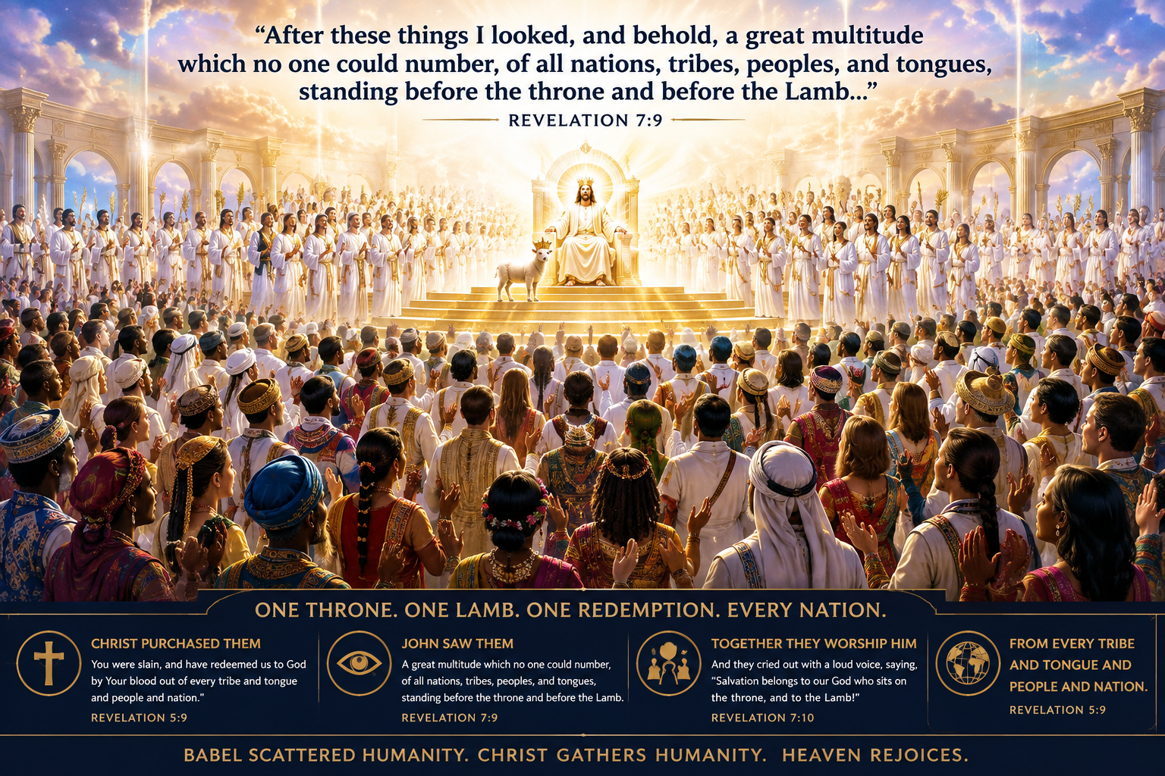
Revelation 7:9-17 — A great multitude from every nation worships before the throne and the Lamb.

Study Notes
1. The Great Multitude, or a Vast Multitude from Every Nation
2. As we come to verses 9-10, John describes an incredible scene of worship before the throne. What is unique about this scene? The diversity! It was a vast multitude of people from ALL nations, tribes, peoples, and tongues.
3. So, why the distinction of every tribe, tongue, people, and nation? This distinction communicates several important theological ideas. What do you think John is trying to communicate here?
a. God doesn’t erase human diversity; He redeems it. John sees people united in worship, but apparently still recognizable as coming from different ethnic, cultural, and linguistic backgrounds. He’s trying to communicate that they all have ONE SAVIOR, ONE SALVATION, ONE THRONE, and ONE WORSHIP.
b. It shows the worldwide scope of the Gospel. The commission of Jesus to His disciples was to make disciples of all the nations. This passage is essentially showing John the finished picture of that mission.
c. It echoes God’s promise to Abraham. Genesis 12:3 says, “in you all the families of the earth shall be blessed.” This verse shows a beautiful fulfillment of that promise. Through Jesus, the promised descendant of Abraham, God’s salvation reaches every nation, tribe, people, and language.
4. Look at the contrast with verses 4-8: Immediately after John hears a specific number (144,000), John sees a number that no one can number.
5. John doesn’t simply say “people” because God wants us to see the reach of redemption. The blood of Christ doesn’t belong to one race, nation, culture, language, or social group. Jesus redeemed people from every corner of humanity, and in heaven their differences no longer divide them. Their common identity in Christ unites them.
6. How were they clothed, and why is it important? They were clothed with white robes, which remind us not only of the covering of Jesus, but also of priestly service.
7. Why the mention of palm branches? Palm branches were emblems of victory. It was showing that this great multitude was celebrating a great victory.
8. What did this multitude shout? “Salvation belongs to our God who sits on the throne, and to the Lamb!”
9. What did this multitude recognize? That God is the source of salvation, and no one else. Salvation isn’t something we earn; it is something God gives.
10. Would you agree that sometimes, as believers on earth, we take our salvation for granted? This contrast with the great multitude is a great reminder for us to always cherish our salvation. Wouldn’t you agree?
11. What happens next, according to verses 11 and 12? All the angels stood around the throne, along with the elders and the four living creatures, and fell on their faces before the throne and worshiped God.
12. What did they declare, and why is it significant? “AMEN! Blessing and glory and wisdom, thanksgiving and honor and power and might, be to our God forever and ever. AMEN!”
a. Heaven is responding to what the redeemed have just declared. Essentially, it functions like a great heavenly doxology—a unified declaration of praise. Imagine hearing this from these heavenly beings: the power and reverence behind it.
b. Notice that the worship begins and ends with AMEN! This gives the worship a sense of completeness and certainty. Everything between those two AMENS is being affirmed as eternally belonging to God.
c. Notice there are SEVEN attributes of praise: blessing, glory, wisdom, thanksgiving, honor, power, and might. Given how important the number seven is throughout Revelation, this is probably not accidental. Each word says something different about God!
13. What an amazing progression we see here: John sees the redeemed; the redeemed proclaim salvation; heaven falls down in worship; heaven declares God’s complete worthiness.
14. I think Revelation 7:12 gives us much more than a description of heavenly worship; it gives us a pattern of what our worship should look like now. If heaven worships God for these seven attributes, shouldn’t these same truths shape how we approach Him?
15. In verses 13-14, we learn the identity of this great multitude. It was important for John to know, but more than likely he didn’t know that he should ask. So what happens? One of the elders prompts him by asking the question for him: “Who are these in glistening white robes, and where have they come from?”
16. What was the elder’s answer? It’s those coming out of the Great Tribulation. The vast multitude are those rescued for God’s kingdom during the period of the Great Tribulation.
17. I think chapter 7 is a significant pause before what’s to come: the judgments as the seals are opened. I think it’s showing John—and us 2,000 years later—that even during the darkest period of judgment the world will ever experience, God will still be saving people.
18. But notice what actually saves them; this may be the most important part of verse 14.
a. They aren’t saved because they survived the Tribulation.
b. They aren’t saved because they suffered.
c. They aren’t saved because they resisted the Antichrist.
d. They are saved exactly the same way anyone is saved: only through Jesus Christ.
19. This is especially important theologically. Why? Because there is only ONE GOSPEL! There is not a gospel for us and another gospel for people during the Tribulation.
20. What ultimately saves them? The blood of the Lamb saves them.
21. The end of verse 14 gives a beautiful paradox in the imagery. Normally, washing something in blood would stain it. But here, blood makes the garment white. It’s intentional. Their sin has been cleansed because Christ’s blood paid for it. The blood that appears to stain is actually the blood that cleanses.
22. What awaits them as we close this amazing chapter with verses 15-17?
a. They experienced persecution; now they serve before God’s throne.
b. They experienced deprivation; they shall hunger and thirst no more!
c. They experienced exposure and suffering; the sun shall not strike them, nor any heat.
d. They experienced death, yet the Lamb becomes their Shepherd.
e. They experienced tremendous sorrow, but God will wipe away every tear from their eyes!
23. One final question: If the darkest period in human history produces a multitude of believers so large no one can count them, what does that tell us about God’s ability to save people even in the worst possible circumstances? God’s judgment never means God’s mercy has disappeared!
24. Even while Revelation describes extraordinary judgment upon the earth, John looks into heaven and discovers that the Gospel is still working, the blood of Jesus is still saving, and people from every nation are still coming to the Lamb! Amen?!!!

